Software Testing
- What is Software Testing?

Software Testing is a method to check whether the actual software product matches expected requirements and to ensure that software product is defect free. It involves execution of software/system components using manual or automated tools to evaluate one or more properties of interest. The purpose of software testing is to identify errors, gaps or missing requirements in contrast to actual requirements.

- Types of Software Testing

- Functional Testing
- Unit Testing
- Integration Testing
- System Testing
- Acceptance Testing

- Non-Functional Testing
- Security Testing
- Performance Testing
- Usability Testing
- Compatibility Testing

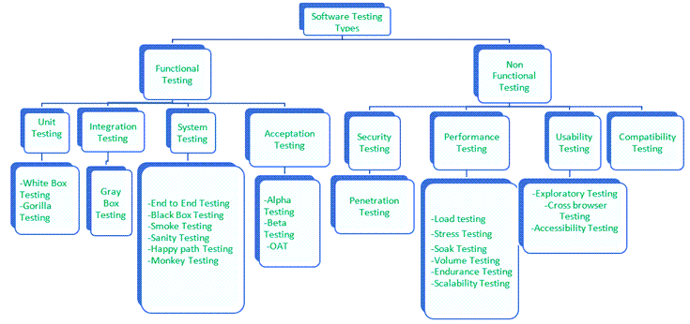

Unit Testing:
- Unit tests are very low level and close to the source of an application. They consist in testing individual methods and functions of the classes, components, or modules used by your software.

Integration Testing:
- Integration tests verify that different modules or services used by your application work well together.

System Testing:
- System testing takes your software is compiled as a whole and then tested as a whole. This testing strategy checks the functionality, security, portability, amongst others.

Acceptance Testing:
- Acceptance tests are formal tests that verify if a system satisfies business requirements. They require the entire application to be running while testing and focus on replicating user behaviors. But they can also go further and measure the performance of the system and reject changes if certain goals are not met.

Security Testing:
- Security Testing is done to check how the software, application, or website is secure from internal and/or external threats. This testing includes how much software is secure from malicious programs, viruses and how secure & strong the authorization and authentication processes are. It also checks how software behaves for any hacker’s attack & malicious programs and how software is maintained for data security after such a hacker attack.

Performance Testing:
- Performance tests evaluate how a system performs under a particular workload. These tests help to measure the reliability, speed, scalability, and responsiveness of an application.

Usability Testing:
- Usability tests validates how well a customer can use a system or web application to complete a task.

Compatibility Testing:
- Compatibility validates how software behaves and runs in a different environment, web servers, hardware, and network environment.

- Why Software Testing?
- Saving money
- Improving security
- Increased product quality
- Higher customer satisfaction
- Enhancing development process

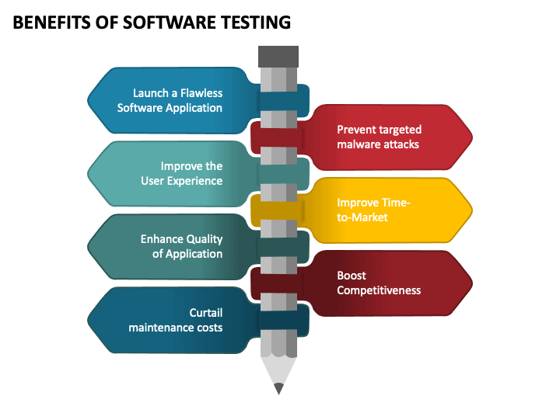

DOT Framework Chosen Research Methods:

- Available product analysis
- Community research
- Document analysis
- Ethical check
- Peer review

Resources:
- https://www.guru99.com/software-testing-introduction-importance.html#1
- https://www.atlassian.com/continuous-delivery/software-testing/types-of-software-testing
- https://www.softwaretestinghelp.com/types-of-software-testing/
- https://www.ibm.com/topics/software-testing
- https://www.youtube.com/watch?v=cl6pNHGHQEQ
- https://ictresearchmethods.nl/Methods

